**St Mary’s Surgery**

Pinfold Health Centre

Field Road

Bloxwich

WS3 3JP

Tel: 01922 775151

[**www.stmarys-surgery.co.uk**](http://www.stmarys-surgery.co.uk)

**Pinfold Health Centre has Suitable access for disabled patients**

**How to register as a Patient with St Mary’s Surgery**

If you would like to register as a patient with St Mary’s we will first ask your current address, if you are within our Practice boundary we will then ask you to complete a registration form, health questionnaire & Summary Care Records (SCR) opt out form (if you do not want your medical information uploaded to SCR). Patients aged 16 + will then need to book in with one of our Practice Nurses for a new patient check. This will be a 20-minute appointment where our Nurses will undergo a brief health check with you (Medical history, Blood pressure, weight etc.)

**Please ask about our online services once you have registered.**

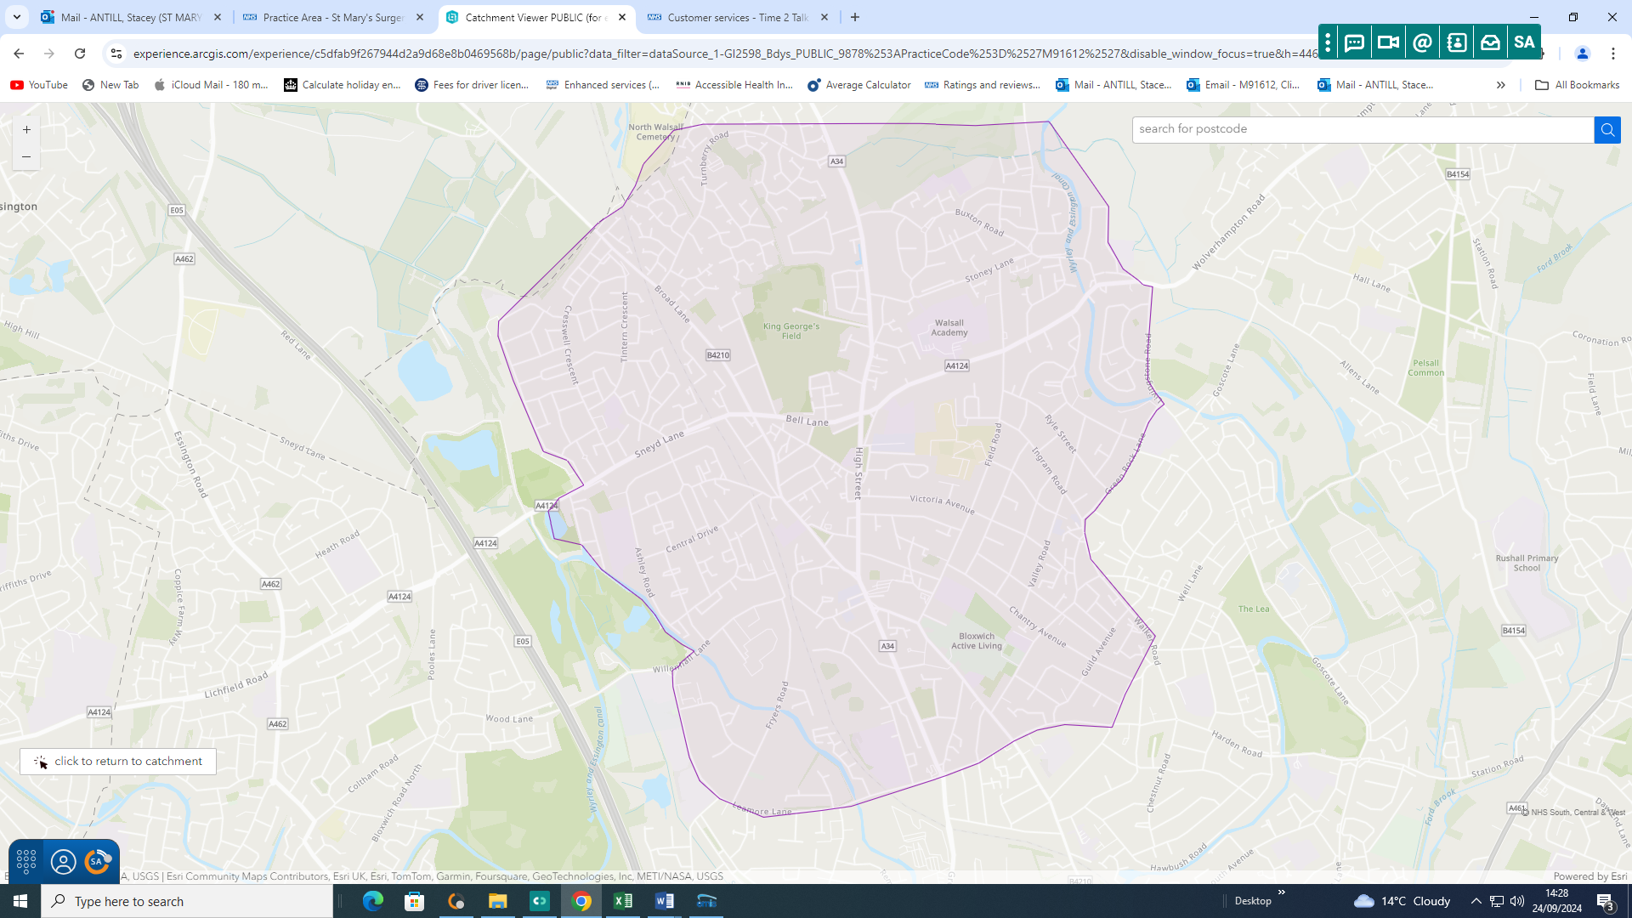

**Our Doctors**

**Dr Dhammika Panagamuwa**

MBBS, MRCGP DFSH

**GP Partner**

**Dr. Mangala Wijetunge (Female)**

MBBS, MRCGP, DRCOG, DFSH

**GP Partner**

***St Mary’s Surgery is not a limited Partnership, and not a training Practice***

***Review Date: 24.02.2025***

**Reception Opening Hours**

*Our Reception opening hours are:*

**Monday: 08:00am – 18:30pm**

**Tuesday: 08:00am – 18:30pm**

**Wednesday: 08:00am – 18:30pm**

**Thursday: 08:00am – 18:30pm\***

**Friday: 08:00am – 13:00pm\***

Our Receptionists will help you with any queries you may have, book appointments, order repeat prescriptions and signpost you to ensure you receive appropriate care from the Practice.

\***OurNet extended access service cover the Practice from 13:00pm – 18:30pm every Friday**

**\*On the last Thursday of every month the Surgery closes at 1pm for staff training.**

**If need medical advice between the hours of 1pm – 6.30pm please contact Ournet on:**

01922 501999

**Practice Participation Group**

We have a PPG within our practice. We are always looking for patients to join our group.

For further information, please ask at Reception.

**Confidentiality & Data Protection**

We record your personal information in order for us to provide you with the appropriate care & treatment. This information is recorded on your computer medical records. We are registered with the Information Commissioner under the Data Protection act as a data controller.

St Mary’s Surgery will ensure that patient confidentiality is maintained at all times by all members of the team.

**ZERO TOLERANCE**

**St Mary’s surgery is committed to a Zero Tolerance approach to abusive language, behaviour or actions. This includes potential or actual physical violence & verbal abuse to Doctors, Practice Staff or other persons present on the premises In the event of actual or threatened violence we reserve the right to contact the police.**

**This could result in removal from the Practice list & the incident will be recorded on your medical records**.

**Weekend & Night Cover**

If you need medical advice when the Surgery is closed, you can contact NHS 111 for medical information & advice.

Ournet also run GP extend access clinics from 6.30pm -9.00pm.

Telephone lines are open form 8.00am to book appointments.

Telephone: 01922 501999

**Home Visit Requests**

Our GP’s can make Home visits for housebound patients, and patients who are unable to come to the surgery due to ill health.

If you feel you are unable to attend the Surgery to see a Doctor, please inform our Reception team. They will then place your name on our Home Visit list which is then assessed by a Doctor. The Doctor will call you to discuss your symptomsto determine if a Home visit is needed. They will also assess the urgency of yourneed for medical attention.

**Reception Opening Hours**

Our Reception will be open:

**Monday: 08:00am – 18:30pm**

**Tuesday: 08:00am – 18:30pm**

**Wednesday: 08:00am – 18:30pm**

**Thursday: 08:00am – 18:30pm\***

**Friday: 08:00am – 13:00pm**

Our Receptionists will help you with any queries you may have, book appointments, order repeat prescriptions and signpost you to ensure you receive appropriate care from the Practice.

**\*On the last Thursday of every month the Surgery closes at 1pm for staff training.**

**If need medical advice between the hours of 1pm – 6.30pm please contact Ournet on:**

01922 501999

**GP Clinic Times**

**Our GP’s offer face-to-face and telephone appointments.**

**Our Receptionists will triage your symptoms when you call.**

**There are certain symptoms that require a face-to-face appointment only; it can be difficult for our GP’s to diagnose certain problems over the telephone.**

**\*If you have any COVID/cold symptoms, you will be asked to do a lateral flow test before you can see a clinician face-to-face**

We offer pre-bookable morning and evening telephone and face-to-face appointments with our Doctors, please call the surgery on: 01922 775151 to book an appointment.

**Repeat Prescriptions**

Repeat prescriptions can be ordered in surgery, by post or via your local pharmacy, or via the NHS App.

Written requests can be placed in the secure box, located just outside reception, or given directly to our receptionists.

We only take telephone requests for repeat prescriptions from housebound patients.

Please do not request repeat prescriptions from the Doctor.

**Please allow 48 hours for us to prepare your prescription.**

**Please ask reception about our online patient services. This service allows you to book appointments, request repeat prescriptions, and view your medical record online.**

**Allocated Accountable GP**

**Every patient at St Mary’s Surgery is allocated a named GP when they register with the Practice.**

**If you would like to know who your named GP is, please ask our receptionists.**

***What does “accountable“ mean?***

The GMS contract required the named accountable GP to take responsibility for the co-ordination of all appropriate services required under the contract and ensure they are delivered to each of their patients where required (based on the clinical judgement of the named accountable GP).  
The contract remains ‘practice based’ so overall responsibility for patient care has not changed.  This is largely a role of oversight, with the requirements being introduced to reassure patients that they have one GP within the practice who is responsible for ensuring that this work is carried out on their behalf.

***What are the named GP's responsibilities to 75s and over?***

for patients aged 75 and over the named accountable GP is responsible for:

* Working with relevant associated health and social care professionals to deliver a multi-disciplinary care package that meets the needs of the patient
* Ensuring that these patients have access to a health check as set out in section 7.9 of the GMS Contract Regulations.

***Does the requirement mean 24-hour responsibility for patients?***

No. The named GP

* Will not take on vicarious responsibility for the work of other doctors or health professionals
* Will not take on 24-hour responsibility for the patient, or have to change their working hours.  The requirement does not imply personal availability for GPs throughout the working week
* Will not be the only GP or **Clinician** who will provide care to that patient

***Can patients choose their own named GP?***

In the first instance, patients should simply be allocated a named GP.  However, if a patient requests a particular GP, reasonable efforts will be made to accommodate their preference, recognising that there are occasions when the practice may not feel the patient’s preference is suitable.

***Do patients have to see the named GP when they book an appointment with the practice?***

No.  Patients can and should feel free to choose to see any GP or Nurse in the practice in line with current arrangements.

**Our Team**

**Practice Manager**

Stacey Antill

***Assistant Practice Manager***

Donna Hinks

**Reception/Administrators**

Carole

Christina

Iris

Jackie

Tracy

Our Receptionists are responsible for taking your phone calls, making your appointments & process your repeat prescription requests. They will ensure your enquires are dealt with as efficiently as possible whilst respecting your confidentiality.

**Practice Nurse**

**Joanne Preece**

***Registered General Nurse, Adult 08/12/1988***

Joanne consults patients by booked appointments. She monitors your medical conditions such as Diabetes, Asthma, Heart disease and COPD. They also offer regular reviews of those with Hypertension, contraception & can offer advice on numerous health related topics, and immunisations.

**Health Care Assistant**

**Danielle Quilt**

*Health & Social Care Level 2*

Danielle has daily clinics for blood tests, ECG’s, new patient checks, NHS health checks, Diabetic foot checks, blood pressure, weight management and basic wound management.

Midwife

Ruth Broadhurst

Ruth holds weekly midwife clinics at the Practice to monitor your pregnancy.

**Practice Paramedic**

Victoria Tapper

*FdSc in Paramedic Science*

Victoria has daily minor ailment clinics and home visits for housebound patients.

**PCN Clinical Pharmacist**

Shaila Naheed

*Master Pharm*

Shaila holds weekly hypertension clinics, medication reviews and can answer any medication queries.

**ICB Practice Pharmacist(s)**

Kamalpreet Parvaz (ICB Pharmacist) and Anmber Sabir Parvaz (ICB Pharmacist)

**Patient Responsibilities**

**The NHS belongs to all of us. There are things that we can all do for ourselves and for one another to help it work effectively, and to ensure resources are used responsibly:**

**You should recognise** that you can make a significant contribution to your own, and your family's, good health and well-being, and take some personal responsibility for it.

**You should register with a GP practice** - the main point of access to NHS care.

**You should treat NHS staff and other patients with respect** and recognise that causing a nuisance or disturbance on NHS premises could result in prosecution.

**You should provide** accurate information about your health, condition and status.

**You should keep appointments,** or cancel within reasonable time. Receiving treatment within the maximum waiting times may be compromised unless you do.

**You should follow the course of treatment** which you have agreed, and talk to your clinician if you find this difficult.

**You should participate** in important public health programmes such as vaccination.

**You should ensure** that those closest to you are aware of your wishes about organ donation.

**NHS Black Country ICB/ NHS England Contact Information**

**Members of the public, patients, and their representatives** can contact NHS England Customer Contact Centre for further help with primary care services (GP, Dentists, pharmacies), enquiries on the number below:

**Telephone:**  **0300 311 22 33**

Website: <https://www.england.nhs.uk/contact-us/>   
**Email:** [england.contactus@nhs.net](mailto:england.contactus@nhs.net)

**NHS Black Country ICB**

NHS Black Country ICBalways welcome comments, questions and input from local people, patients and stakeholders. Depending on the nature of your enquiry, there are a number of ways to contact us. If you don't find the team you need in the list below, simply fill out the form at the bottom of the page and it will be directed to the right person or team.

**General enquiry form:** <https://blackcountry.icb.nhs.uk/contact-us>

**Address:**

NHS Black Country ICB, Civic Centre, St Peter’s Square, Wolverhampton WV1 1SH

**Switch Board:**

0300 0120 281

**Complaints**

If you have any concerns about the service or care that you receive from St Mary Surgery, please ask to speak to the Practice Manager. She will make every effort to see you immediately however this may not always be possible therefore an appointment may be made for you to speak to her within 24 hours.

Formal complaints must be made in writing & addressed to the Practice Manager who will then deal with your complaint in line with our Complaints Procedure.

You also have the option to speak to the time2talk team. The team can pass on any compliments to the relevant team or person. This information can help us, not only to learn from patients’ experiences, but to make improvements to local services.

* Telephone: 0300 0120 281 option 1
* Email: [bcicb.time2talk@nhs.net](mailto:bcicb.time2talk@nhs.net)
* Post: Time2talk

NHS Black Country Integrated Care Board (ICB)

Civic Centre, St Peter’s Square, Wolverhampton

WV1 1SH

**Operational Hours: Monday – Friday (excluding bank holidays) 9:00am – 5:00pm**

For further information, please visit the Time2Talk website: <https://blackcountry.icb.nhs.uk/have-your-say/time-2-talk>

**Unhappy with the outcome of your complaint?**

If you are unhappy with the way your complaint has been dealt with, and feel you would like to take the matter further, you can contact the Parliamentary and Health Service Ombudsman (PHSO). They make final decisions on unresolved complaints about the NHS in England. It is an independent service, which is free for everyone to use.

To take your complaint to the Ombudsman, you can visit the [Parliamentary and Health Service Ombudsman website](http://www.ombudsman.org.uk/make-a-complaint): www.ombudsman.org.uk/making-complaint, **or call 0345 015 4033**. Monday to Thursday from 8.30am to 5.00pm and Friday from 8.30am to 12pm (except bank holidays). .

You can also email: [phso.enquiries@ombudsman.org.uk](mailto:phso.enquiries@ombudsman.org.uk)